**Ex. No.: 8**

**Date: 13.04.2024**

**PRODUCER CONSUMER USING SEMAPHORES**

**Aim:**

To write a program to implement solution to producer consumer problem using semaphores.

**Program Code:**

#include <stdio.h>

#include <stdlib.h>

int mutex = 1, full = 0, empty = 3, x = 0;

void producer();

void consumer();

int wait(int);

int signal(int);

int main() {

int n;

printf("\n1.Producer\n2.Consumer\n3.Exit");

while (1) {

printf("\nEnter your choice: ");

scanf("%d", &n);

switch (n) {

case 1:

if ((mutex == 1) && (empty != 0))

producer();

else

printf("Buffer is full!!");

break;

case 2:

if ((mutex == 1) && (full != 0))

consumer();

else

printf("Buffer is empty!!");

break;

case 3:

exit(0);

break;

}

}

return 0;

}

int wait(int s) {

return (--s);

}

int signal(int s) {

return (++s);

}

void producer() {

mutex = wait(mutex);

full = signal(full);

empty = wait(empty);

x++;

printf("\nProducer produces the item %d", x);

mutex = signal(mutex);

}

void consumer() {

mutex = wait(mutex);

full = wait(full);

empty = signal(empty);

printf("\nConsumer consumes item %d", x);

x--;

mutex = signal(mutex);

}

**Output:**

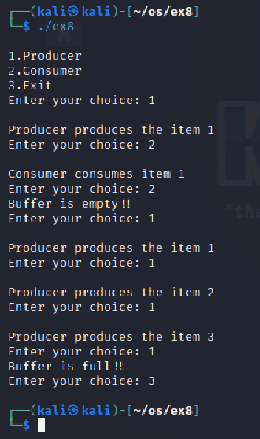

**Result:**

The above program executed successfully and output got verified.